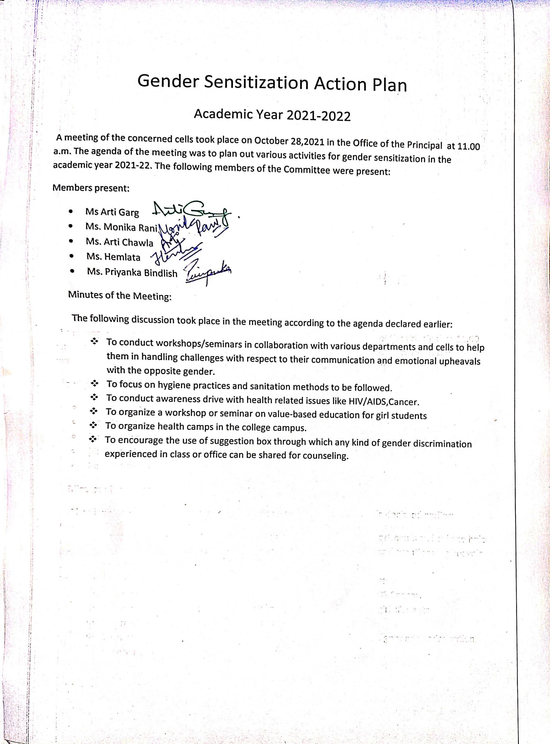

Gender Sensitization
List of Activities
Sr. No | Events | Organized By | Topic | Outcomes | Pics
1. | Online State level Essay Writing and Declamation competition | Women Cell of  I.G.M.M.V Kaithal | (i)Health and Hygiene: Women  (ii)Empowered women- Empowered India | Women cell of our college organized online state level essay writing and declamation competition on june 1,2022.  One student of our college participated in state level online essay writing competition and one student in Declamation. | 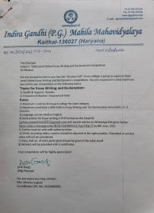
2. | 15 days yoga camp | Sports Department of  I.G.M.M.V Kaithal | Different Yoga asanas,Breathing Techniques,Meditation | A 15 days camp of yoga for Girls ‘was organized by the sports department of College from 17th May to 30th May,2022 to develop healthy habbits during covid-19 among the girl students.  Practical Self yoga Skills were also demonstrated in this camp | 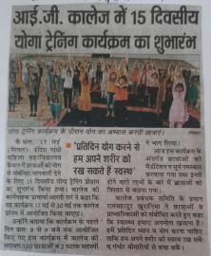
3. | Women's Health Awareness Program | Home Science Department of  I.G.M.M.V Kaithal | Health and Hygiene | The discussion led to awareness amidst girl students regarding the importance of good health & hygiene.  Girl students learnt how to identify their personal health problems and how to deal with them.  The girl students were provided information about how to maintain good health and hygiene in daily life. | 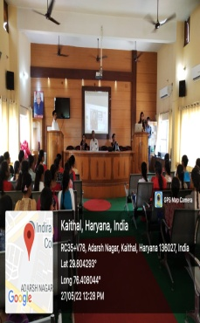
4. | Lecture delivered  Power Point Presentation  Guidance talk  Cancer Awareness Program | Red cross and Red ribbon Cell of  I.G.M.M.V Kaithal  N.S.S in collaboration with  Red cross and Red ribbon Cell of  I.G.M.M.V Kaithal | TB, mental and health issues and HIV/AIDS  TB, Cancer and HIV/AIDS  Drug Addiction,health and mental issues  Cancer, its types and its early detection | On 14th December 2021, a lecture was delivered by red ribbon club of our college. In this lecture the girls were educated on topic health and mental issues by resource person.  On 14th April 2022 PPT was given by the students of our college on different topics : HIV/AIDS,TB, Cancer etc.  - A lecture was delievered on 15th june 2022 in our college on the topic Drug Addiction and Mental Issues. The resource person was Dr. Vinay Gupta and his assistant Mr. Sushil Sharma from the Civil Hospital,Kaithal.  - A lecture was delivered for creating awareness among girls student about the various drugs used by the addicts and its short term and long term effects which may lead to health problems,harmful effects on the brain and genetic disorders.  - On 23-06-2022, an awareness rally was organized by “Red Cross and Red Ribbon Cell”.In this rally  students raised slogans against Drug Addiction  On 25 March 2022, A “Cancer Awareness” program was organized by Red Cross and  Red Ribbon Cell under N.S.S. Camp. Dr. Jay Gopal Sharma Cancer Specialist from BL K -  MAX hospital, Delhi provided valuable information about cancer, its types and its  early detection to our girls. | 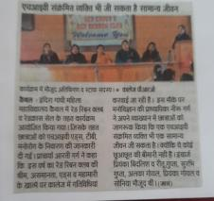  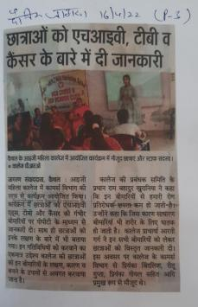  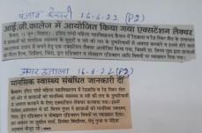  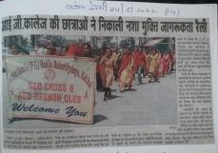  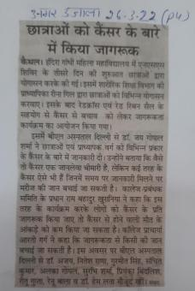
5. | Poster making competition  Documentary | ICCASH of I.G.M.M.V.,KAITHAL | Stop woman harassment  Female a victim of Evolution –Sexual Assault on Indian Women | Poster making competition was organized in the college premises on 7 March,2022. The main purpose was to create awareness among girls about harassment.  To create awareness among girls, a Documentary was shown to the students on 11th june ,2022. A lecture related to harassment and what to do if someone faces any kind of harassment was also delivered to the students. | 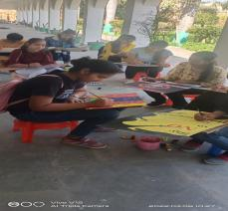  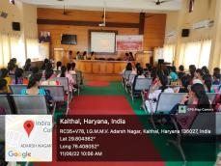
6. | Lecture | N.S.S in collaboration with Commerce Department of I.G.M.M.V.,KAITHAL | Atamnirbhar Bharat | Lecture was delivered on Information regarding Women Entrepreneurship on 23 March 2022. | 