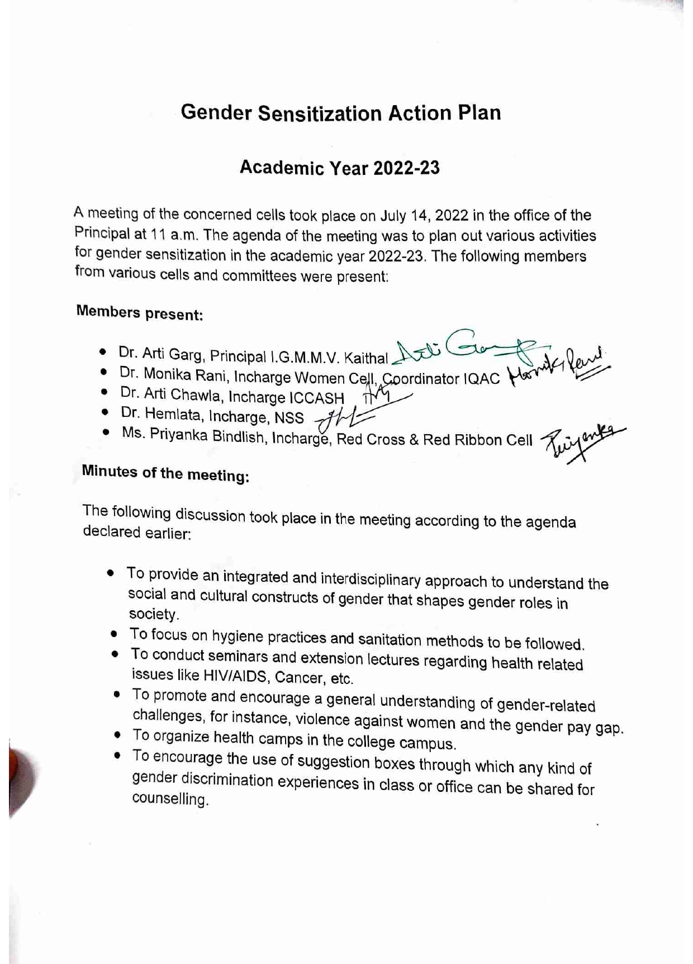

Gender Sensitization
List of Activities
Sr. No | Events | Organized By | Topic | Outcomes | Pics
1. | Nukkad Natak | Women Cell of  I.G.M.M.V Kaithal | Women Exploitation, Sexual Harassment | Women cell of our college organizedNukkad Natakon 09.12.2022 to aware students about Women Exploitation, Sexual Harassment | 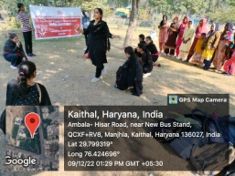
2. | National Level Poster Making and Slogan Writing Competition | Women Cell of  I.G.M.M.V.  Kaithal | Stand up for women | Women cell of our college organized National Level Poster Making and Slogan Writing Competition under the theme “Stand up for women” on 25.04.2023 to aware the girl students about women’s rights, what women’s rights actually are and what a women can do for herself and stand up among the society. | 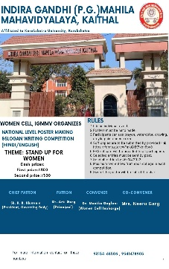
3 | Self defence training  programme | I.G.M.M.V.  Kaithal |  | A self defence training programme was organized by ICCASH of our college on 31st march2023 to aware girls of their surroundings and be prepared for unexpected incident at any time. Girls are taught to become psychologically, intellectually and physically strong enough to protect themselves in times of distress. | 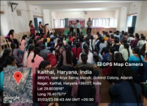
4. | Art of  Living | Dept of  Health  and  Physical  Education, I.G.M.M.V.  Kaithal | Meditation, Breathing Techniques | An Art of Living Happiness Program was organized by Dept ofHealth  AndPhysical  Education of our College on 24.02.2023. The program helped the girls and the staff to live the life the way they have always wanted to through a tried and tested combination of yoga, breathing exercises , meditation and practical wisdom. | 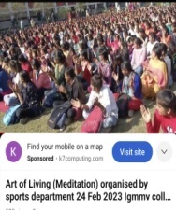
5. | Training Camp of Yoga- 15 days | Dept of  Health  and  Physical  Education, I.G.M.M.V.  Kaithal |  | Training Camp of Yoga- 15 dayswas organized by Dept of Health  And Physical  Education of our College to train the girls to focus on yoga for strength, flexibility and relaxation. The girls were taught how to increase concentration and how to decrease anxiety with the help of yoga. | 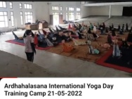
6. | Health & Physical Awareness Camp | Dept of  Health  and  Physical  Education, I.G.M.M.V.  Kaithal |  | Health & Physical Awareness Campwas organized by Dept of Health  And Physical  Education of our College from28.09.2023 to 29.03.2023 to make girls learn about specific health and wellness solution. Fitness demonstrations like yoga, aerobics and other fitness activities were organized in this camp. | 
7 | Rally | Sexual  Harassment  and  Grievance  Cell,I.G.M.M.V.  KAITHAL | Stop  Sexual  Harassment | Sexual  Harassment  and  Grievance  Cell of our college organized a rally on Stop  Sexual  Harassment on 28.03.2023to make students aware about sexual harassment and aquaint the girls about the procedure to make complaints if they have any problem regarding sexual harassment | 