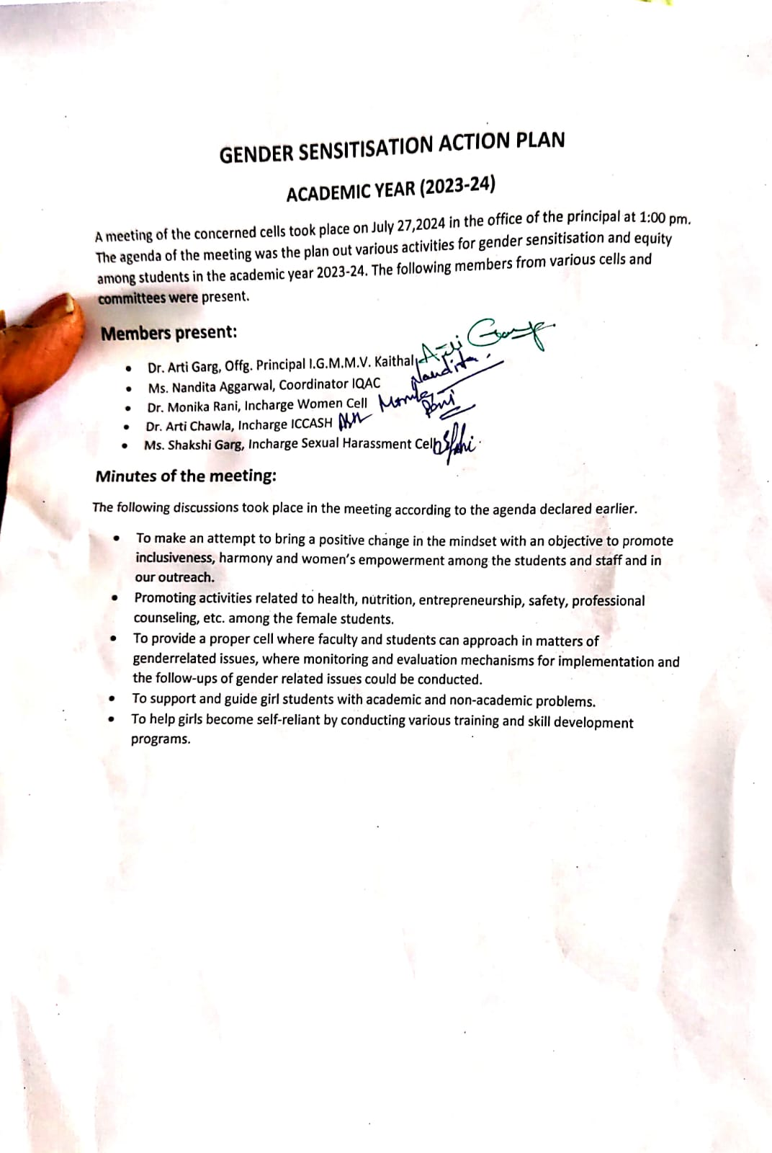
Gender Sensitization
List of Activities
Sr. No | Events | Organized By | Topic | Outcomes | Pics
1. | State Level Essay Writing compettion  International Girl Child Day | Women Cell of  I.G.M.M.V Kaithal | Save girl child  Stop Infanticide  Schemes of Haryana Govt for Girl child | Women cell of our college organized a state level competition on 11.10.2023 to bring attention to critical issues like female ifenticide. | 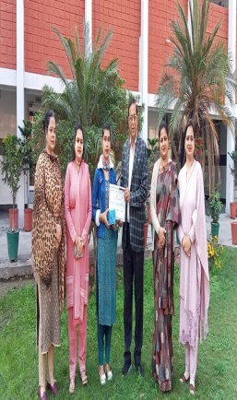
2. | National Level Online Essay Writing Competition | Women Cell of  I.G.M.M.V.  Kaithal | Empowering Girls : Ensuring Equality and Opportunity | Women cell of our college organized National Level Online Essay Writing Competition held on  24.01.2024. it leads to greater equality, education and benifitting entire communities. | 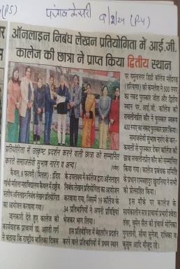
3 | State Level Slogan Writing Competition | Women Cell of  I.G.M.M.V.  Kaithal | Gender Sensitization and Mental Health of Women | Women cell of our college organized state level slogan writing competition on 08.03.2024, for promotes supportive communities and policies, fostering improved mental well-being and equality. | 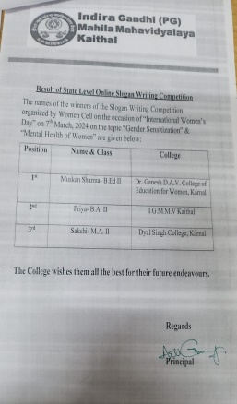
4. | Group Discussion | Women Cell of  I.G.M.M.V.  Kaithal | Rights and duties of women  Women Empowerment  Gender Discrimination  Need of Education for Women | Women cell of our college organized a group discussion on 07.03.2024. it drives economic growth, social progress and gender equality, benefiting communities and nations. | 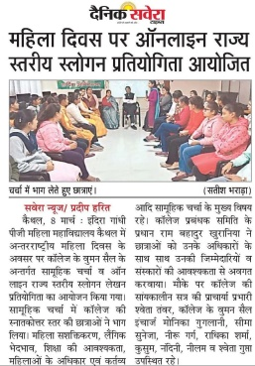
5. | Exhibition | NSS and EDP Cell(entrepreneurship development program) | Self-Reliant India Campaign | Exhibition was organized by NSS and EDP Cell (entrepreneurship development program) of our college on 13.02.2024 for showcased handmade items created by students for sale. The aim of this initiative was to provide youth with opportunities to showcase their talents, foster creativity and promote entrepreneurship. | 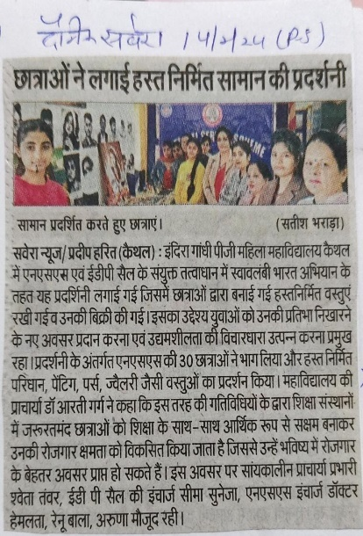
6. | PowerPoint Presentation on ‘Sexual Harassment’ | Sexual  Harassment  and  Grievance  Cellin collaboration with Computer Science Department,  I.G.M.M.V.  KAITHAL | The impact of sexual harassment on victims | Sexual  Harassment  and  Grievance  Cellin collaboration with Computer Science Department of our college organized a ppt on The impact of SexualHarassment on victims on 17.10.2023 to make students aware about sexual harassment and aquaint the girls about the procedure to make complaints if they have any problem regarding sexual harassment | 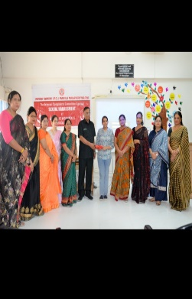
7 | Documentary on POSH Act 2013 | Sexual Harassment and Grievance Cell in collaboration with ICCASH,  I.G.M.M.V.  KAITHAL | The Legal Framework of the POSH Act | Sexual  Harassment  and  Grievance  Cellin collaboration with ICCASH of our college shows a documentary on the POSH Act on  9.02.2024 awareness aboutThe POSH (Prevention of Sexual Harassment) Act, formally known as the Sexual Harassment of Women at Workplace (Prevention, Prohibition and Redressal) Act, 2013, provides a comprehensive legal framework to address sexual harassment in the workplace in India. | 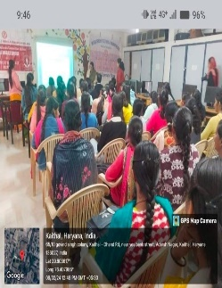
8. | Awareness Program about crimes against women | Sexual Harassment and Grievance Cell in collaboration with Redressal Cell | Sexual harassment:understanding the laws and how to speak up | Awareness Program about crimes against women organized by  Sexual Harassment and Grievance Cell in collaboration with Redressal Cell of our college on 12.4.2024. The program increased awareness among students about various forms of crimes against women and the legal protections available. It empowered students to recognize and report such incidents, fostering a supportive environment. Additionally, the initiative promoted gender sensitivity and respect, contributing to a safer and more inclusive campus community. | 